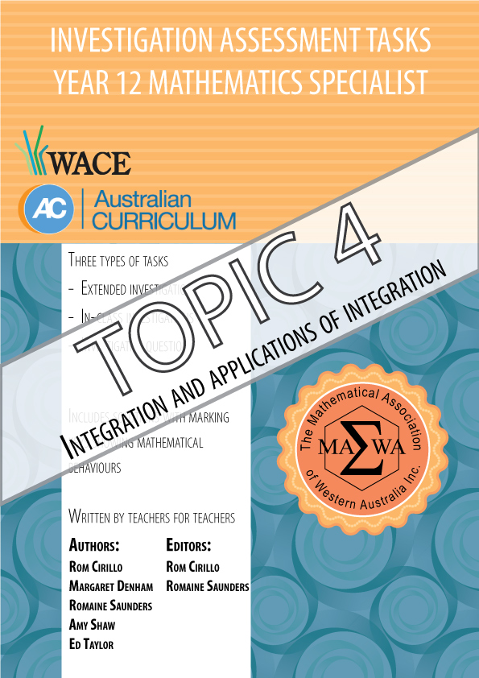

For each topic three types of tasks are included:
- Extended investigation – an investigation which could be done in the student’s own time followed by an in-class validation. Solutions are provided where practicable for the preparation activity/investigation. For the in-class validation, there are solutions and marking keys which identify the mathematical behaviours that students may exhibit.
- In-class investigation – an investigation for which no prior preparation is required. Solutions and marking keys are provided.
- Investigative questions – a series of short questions which test the student’s ability to apply their learning, to justify their conclusions, to investigate and to generalise, or to solve problems. Such questions could be included in a response or examination assessment. Solutions and marking key are provided.

Screen shot have been produced using the CASIO ClassPad II emulator or the
ti-nspire CAS emulator.

Most graphs and diagrams have been produced using efofex software.

© The investigations and solutions in this publication are for the sole use of staff and students of the purchasing school. It is a breach of copyright to distribute them in whole or part in any form now or in the future to any other school, company or person.

Contents:
MATHEMATICS SPECIALIST: Year 12

3.1 Complex numbers
Task 1: Extended investigation: The Factor and Remainder Theorems
Task 2: In-class investigation: Complex numbers using e^{iθ}
Task 3: Investigative questions

3.2 Functions and sketching graphs
Task 4: Extended investigation: The graphs of rational functions
Task 5: In-class investigation: The absolute value function
Task 6: Investigative questions

3.3 Vectors in three dimensions
Task7: Extended investigation: Systems of equations
Task 8: In-class investigation: Cross product
Task 9: Investigative questions

4.1 Integration and applications of integration
Task10: Extended investigation: The Golden Gate bridge
Task 11: In-class investigation: Which sculpture
Task 12: Investigative questions

4.2 Rates of change and differential equations
Task13: Extended investigation: Time of death
Task 14: In-class investigation: The logistic function
Task 15: Investigative questions

4.3 Statistical inference
Task16: Extended investigation: TBA
Task 17: In-class investigation: TBA
Task 18: Investigative questions

This package only contains the investigations associated with topic 4.1: Integration and applications of integration

If your school has purchased the complete set of 18 investigations, you will be informed when the rest are ready for delivery/download.

TASK 10: SUSPENSION CABLES

Extended investigation

Unit 4

Topic 4.1: Integration and applications of integration

Course-related information

The concepts and skills included in this investigation relate to the following dot points within the WA Mathematics Specialist syllabus.
4.1.5 calculate areas between curves determined by functions
4.1.6 determine volumes of solids of revolution about either axis
4.1.7 use technology with numerical integration

This task provides opportunities for students to consider the suspension cable that is used in suspension bridges. The ability to choose and use appropriate technology to enhance and extend concept development is also incorporated within some of the items.

Background information

The mathematical skills and understandings that students would need for this task should have been covered in earlier years and also in WA Mathematics Methods 3.2.10 - 3.2.14, 3.2.17, 3.2.19 and 3.2.20.

Task conditions

For this task students would need access to a CAS calculator. No student notes are required; formulae are provided. Students are expected to complete the preparation activity before the in-class validation

SUSPENSION CABLES

Extended investigation Part 1: Preparation activity

A uniform, non-elastic, and infinitely flexible cable or wire suspended from two fixed points under the influence of gravity forms a catenary. A catenary is similar in shape to a parabola. In 1646, Huygens was able to demonstrate that a catenary is not a parabola and thus refute Galileo’s assertion that a catenary is a parabola.

The equation of a catenary with the vertex at may be expressed in the form where .

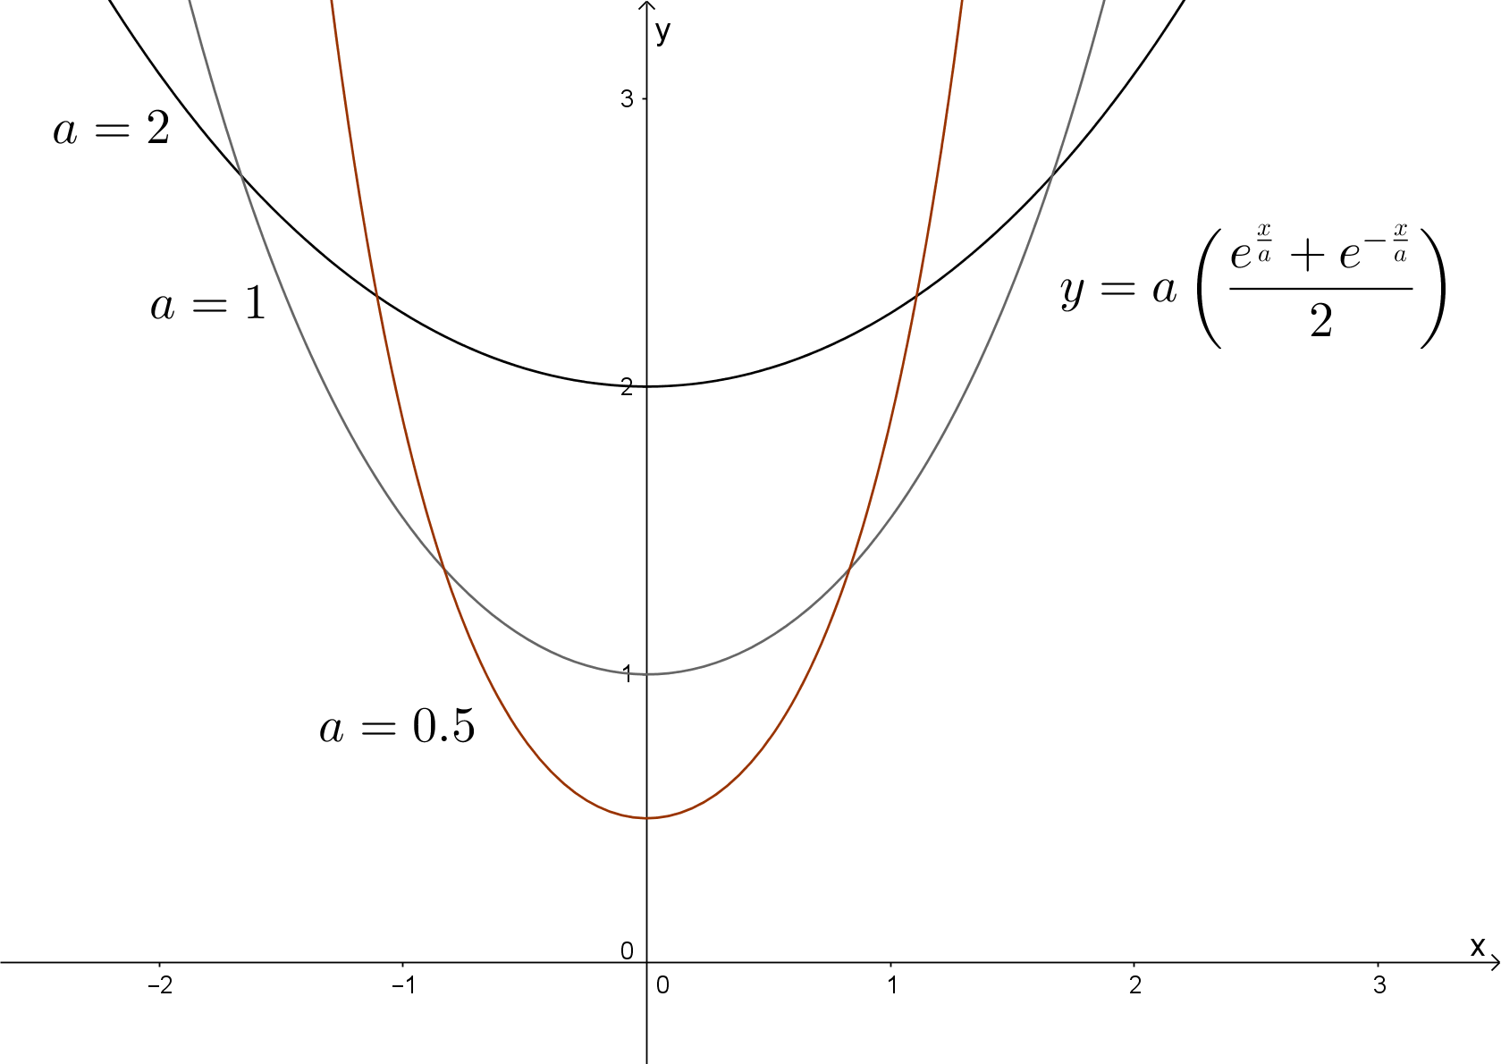

Question 1

(a) Determine the area enclosed by the two curves defined for and .

(b) Determine the volume of the solid formed by rotating the area enclosed in (a) through one revolution about the horizontal axis.

(c) Determine the volume of the solid formed by rotating the area enclosed by the curves and through one revolution about the vertical axis.

A catenary curve is created by its own weight, pulling down because of gravity.
The hanging chain in the picture below is only holding its own weight. The curve it creates is a catenary.

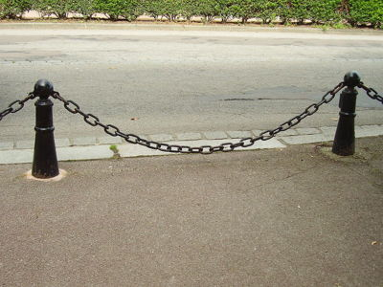
http://mathforum.org/mathimages/index.php/Image:Catenary3.jpg

Suspension bridges feature a deck with vertical cables called hangers or vertical suspenders that are connected to the two large main cables that are under tension from the weight of the deck of the bridge. The way these two large cables are hung resemble the shape of a parabola.

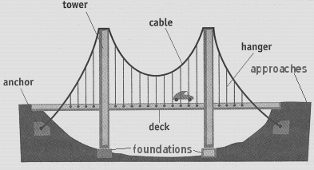
http://mathforum.org/mathimages/index.php/Image:Anatomy.gif

The curves of the suspension cable are not created by gravity alone; other forces, such as compression and tension, act on it. It is also supporting the weight of the deck.

The main span of the Golden Gate Bridge in San Francisco, USA, has two main cables which pass over the tops of two 227 m tall towers. The central span of the Golden Gate Bridge is 1280 m long and consists of two main towers and supporting cables. The height of a tower above water is 227 m, the height of a tower above the roadway is 152 m.
The weight of the roadway is supported by two cables that pass through the two main towers and are fixed in concrete at each end. Each cable is made of 27,572 strands of wire. There are 129,000 km of wire in the main cables. The bridge has approximately 1,200,000 rivets.

The central span of the Golden Gate Bridge has 84 pairs of equally spaced vertical suspenders that connect the bridge to the large cables.

Question 2
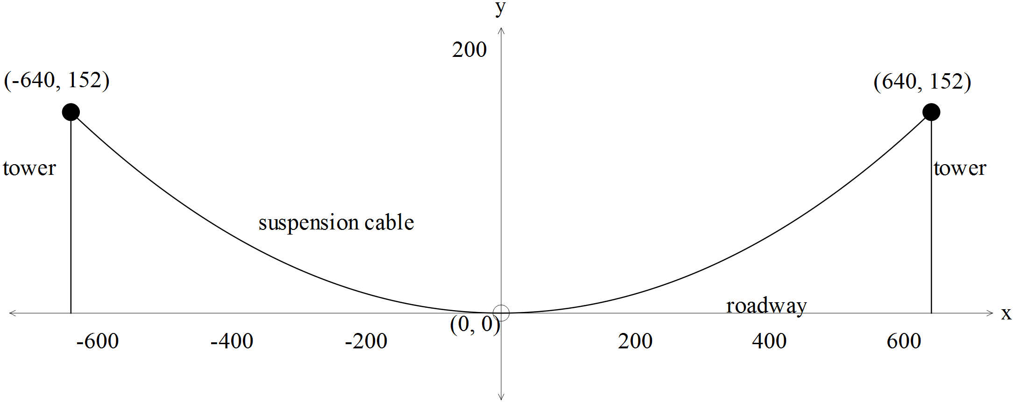

(a) Given the dimensions on the diagram above, check that the curve of the suspension cable may be approximated by the catenary function
.

(b) Using the equation of the curve in (a), determine the area enclosed by the suspension cable, the roadway and the two tall towers.

(c) Hence, determine the approximate total length of the vertical suspenders that connect the bridge to a suspension cable in the central span of the Golden Gate Bridge.

The Golden Gate Bridge is almost the shape of a catenary; it is also almost the shape of a parabola.

Question 3
(a) Determine the equation of the parabola, , that approximates the curve of the suspension cable.

(b) Use the parabolic function to determine the approximate total length of the vertical suspenders that connect the bridge to a suspension cable in the central span of the Golden Gate Bridge. Compare with your answer in Question 1(c).

The length, , of an arc of the curve between is given by .

Question 4
Compare
(a) the graphs of the catenary and parabolic functions.

(b) the length of the suspension cable using the catenary function with the length of the suspension cable using the parabolic function.

SUSPENSION CABLES

Extended investigation Part 1: Preparation activity
Solutions

Question 1(a)
Solution
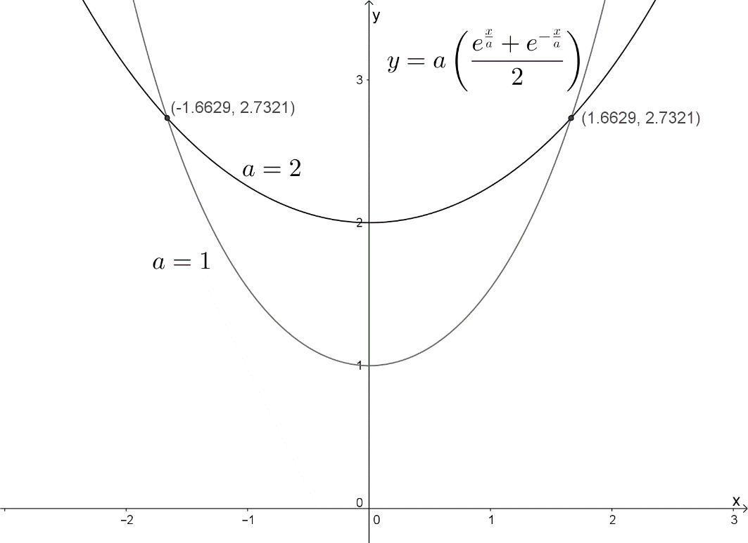

Question 1(b)
Solution

Question 1(c)
Solution
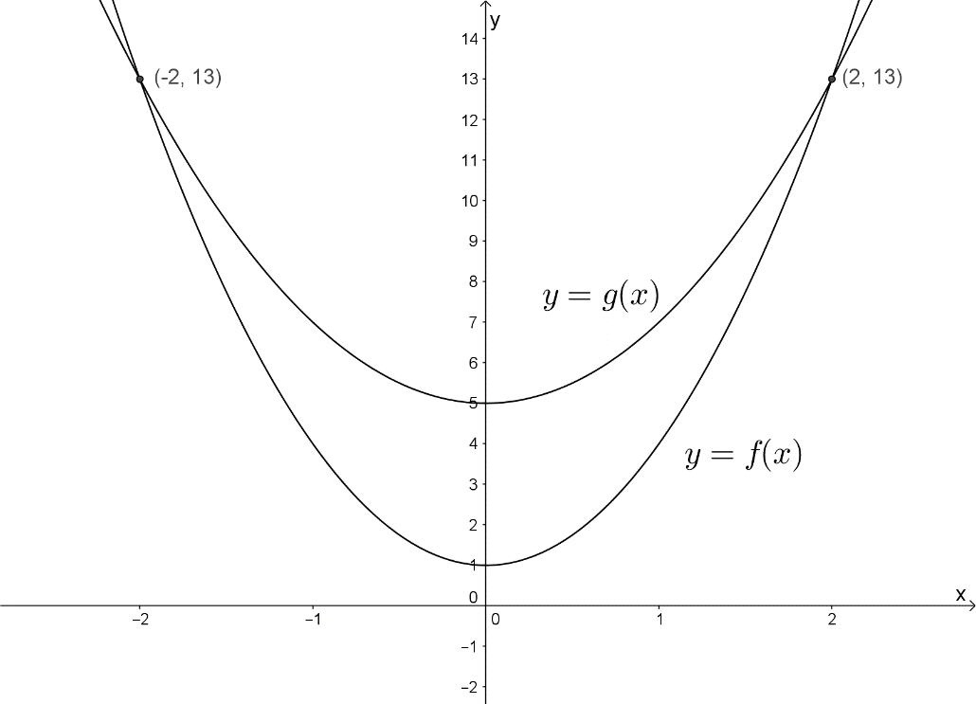
and

Question 2(a)
Solution
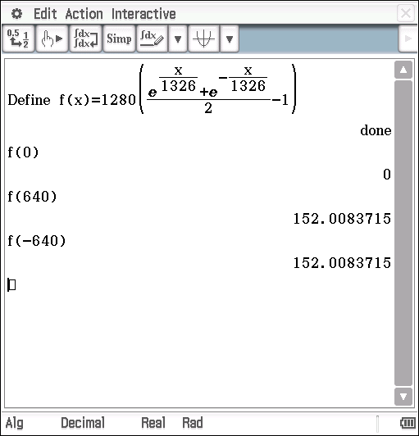

Since , it appears that the curve of the suspension cable may be approximated by the catenary function.

Question 2(b)
Solution

Question 2(c)
Solution
The 84 equally spaced vertical suspenders divide the interval into 85 equal width sub-intervals.

Question 3(a)
Solution
The parabola has a minimum turning point at , hence .
The points lie on the parabola, hence

Question 3(b)
Solution

The approximate total length of the vertical suspenders is approx. 33 m more using the parabolic function.

Question 4(a)
Solution
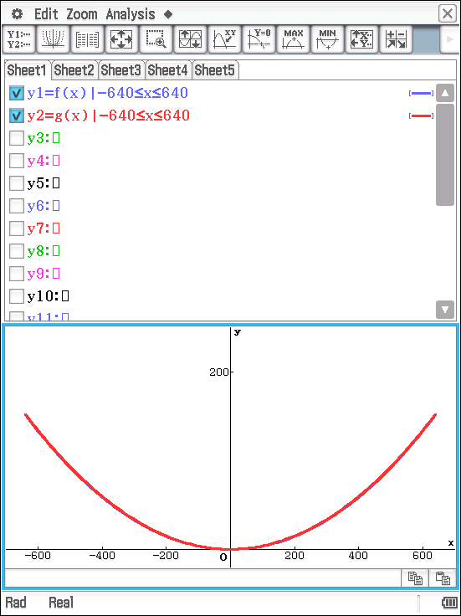

The graphs of the catenary function , and the graph of the parabolic function , are shown above.

They appear to be the same curve.

Question 4(b)
Solution
Using the catenary function, ,
Using CAS,

Using the parabolic function, ,
Using CAS,

The length of the suspension cable is the same to the nearest metre.

SUSPENSION CABLES

Extended investigation Part 2: In-class validation

The length, , of an arc of the curve between is given by .

Question 1 (4 marks)

(a) Determine the area enclosed between and . (2)

(b) Determine the volume of the solid formed by rotating this enclosed area through one revolution about the horizontal axis. (2)

The Clifton Suspension Bridge at Bristol stands 75 m above the water in the gorge through which the river Avon flows. The two suspension cables hang from the two towers 26 m above the roadway. The two towers are 214 m apart.

The supporting cable can be modelled by the catenary function
as shown in the diagram below.

The central span of the Clifton Suspension Bridge has 70 pairs of equally spaced vertical suspenders that connect the bridge to the large cables.

Question 2 (6 marks)

Use the catenary function to determine the approximate total length of the vertical suspenders that connect the bridge to a suspension cable in the central span of the Clifton Suspension Bridge.

Question 3 (6 marks)

(a) Determine the equation of the parabolic function that approximates the curve of the supporting cable of the Clifton Suspension Bridge. (3)

(b) Use the parabolic function to determine the approximate total length of the vertical suspenders that connect the bridge to a suspension cable in the central span of the Clifton Suspension Bridge. Compare with your answer in Question 2.
(3)

Question 4 (10 marks)

Compare
(a) the graphs of the catenary and parabolic functions that approximate the curve of the supporting cable of the Clifton Suspension Bridge. (3)

(b) the length of the suspension cable using the catenary function with the length of the suspension cable using the parabolic function. (3)

The Clifton Suspension Bridge suspension cables extend 100 m symmetrically on either side of the tall towers as shown in the diagram below.

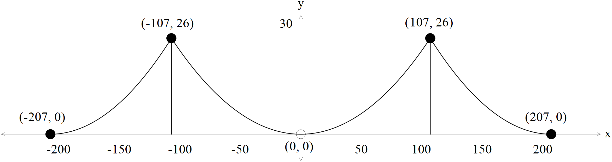

(c) Assuming that these side curves can be modelled using a parabolic function, estimate the total length of this suspension cable. (4)

Question 5 (9 marks)

A suspension bridge has a cable which is suspended from two supporting towers m above the roadway. The towers are m apart. Take the origin to be the lowest point of the cable.

(a) Determine, in terms of , the parabolic function that approximates the curve of the suspension cable. (2)

The equation is the differential equation for this suspension cable.

(b) Show that satisfies this differential equation. (2)

Given the binomial expansion ,

(c) show that the length of the suspension cable may be given by
.
(5)

Question 6 (5 marks)

A suspension bridge has a cable which is suspended from two points A and B that are 225 m apart and are not on the same horizontal line. Point A is 15 m above the roadway; point B is 60 m above the roadway. The origin is taken at the lowest point of the cable.

Find the total length of this cable.

SUSPENSION CABLES

Extended investigation Part 2: In-class validation
Solutions and marking key

Question 1(a)
Solution
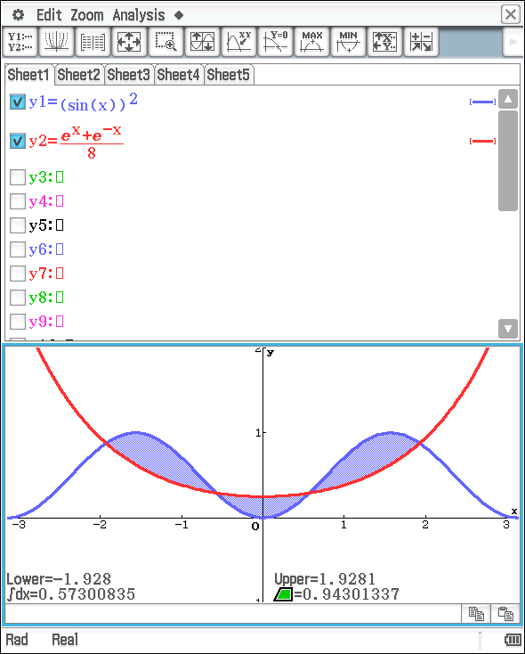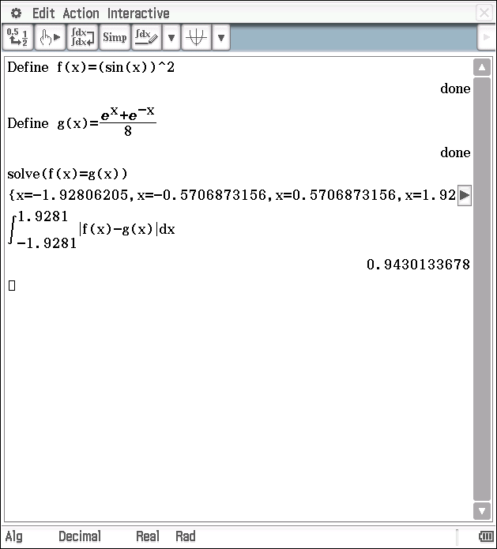
.
Marking key/Mathematical behaviours | Marks
- Determines points of intersection  - Calculates enclosed area | 1  1

Question 1(b)
Solution
Marking key/Mathematical behaviours | Marks
- Chooses correct expression for volume  - Calculates volume | 1  1

Question 2
Solution
The 70 equally spaced vertical suspenders divide the interval into 71 equal width sub-intervals.

Marking key/Mathematical behaviours | Marks
- Determines there are 71 sub-intervals  - Writes down an expression for the area under the curve  - Approximates area using a Riemann sum  - Correctly calculates the width of each sub-interval  - Determines an expression for the total length  - Calculates the approx. total length of the vertical suspenders | 1  1  1  1  1  1

Question 3(a)
Solution
The parabola has a minimum turning point at , hence .
The points lie on the parabola, hence
Marking key/Mathematical behaviours | Marks
- Recognises  - Identifies points on the parabola  - Substitutes to obtain equation of function | 1  1  1

Question 3(b)
Solution

The approximate total length of the vertical suspenders is approx. 3 m more using the parabolic function.

Marking key/Mathematical behaviours | Marks
- Calculates the height of the rectangle  - Calculates the approx. total length of the vertical suspenders  - Compares the lengths | 1  1  1

Question 4(a)
Solution
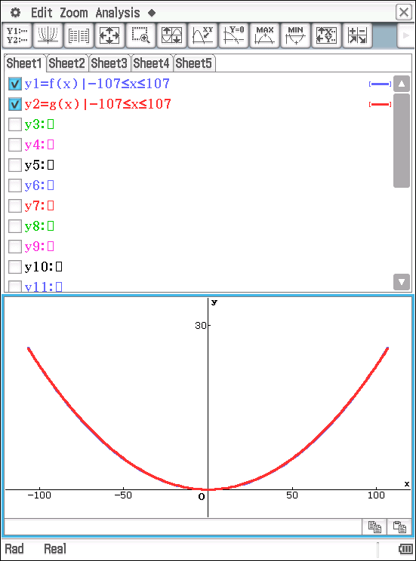
The graphs of the catenary function , and the graph of the parabolic function , are shown above.

They appear to be the same curve.

Marking key/Mathematical behaviours | Marks
- Draws graph of  - Draws graph of  - Comments on the similarity | 1  1  1

Question 4(b)
Solution
Using the catenary function, ,
Using CAS,

Using the parabolic function, ,
Using CAS,

The length of the suspension cable is the same to the nearest metre.
Marking key/Mathematical behaviours | Marks
- Calculates length using  - Draws length using  - Comments on the similarity | 1  1  1

Question 4(c)
Solution
, is the equation of the parabola that passes through the points.
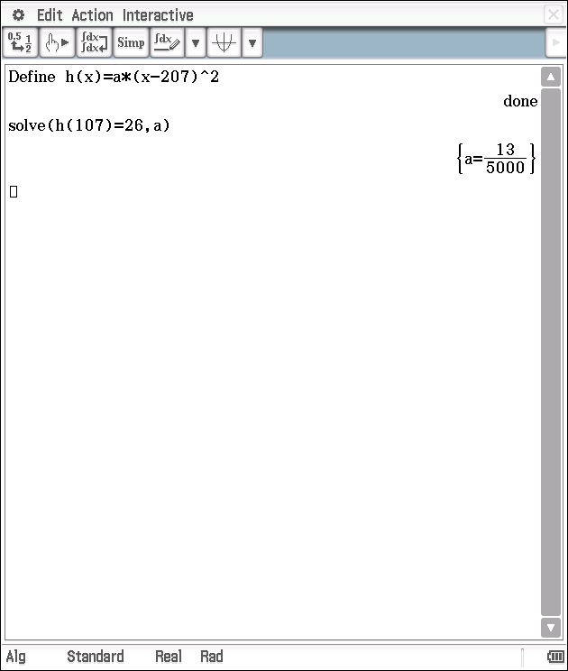

If, instead, the catenary function is used, the total length is approx. 431 m.
Marking key/Mathematical behaviours | Marks
- Determines turning point of parabolic function is either  - Recognises parabolic function is of the form  - Determines parabolic function for either left or right side  - Calculates total length | 1  1  1  1

Question 5(a)
Solution
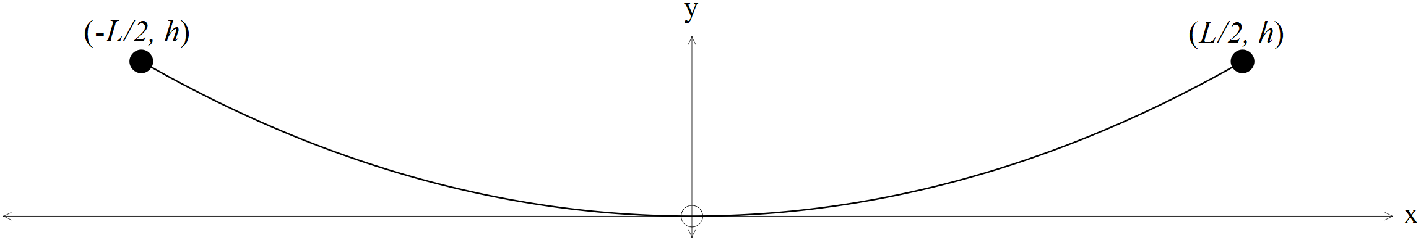
The parabola has a minimum turning point at and contains the points .
Marking key/Mathematical behaviours | Marks
- Recognises  - Substitutes to obtain equation of function | 1  1

Question 5(b)
Solution
Marking key/Mathematical behaviours | Marks
- Correctly determines  - Correctly determines | 1  1

Question 5(c)
Solution
Marking key/Mathematical behaviours | Marks
- Substitutes correctly for in terms of  - Correct substitution into binomial expansion  - Correct antiderivative  - Substitutes upper and lower limits of integration  - Simplifies correctly | 1  1  1  1  1

Question 6
Solution
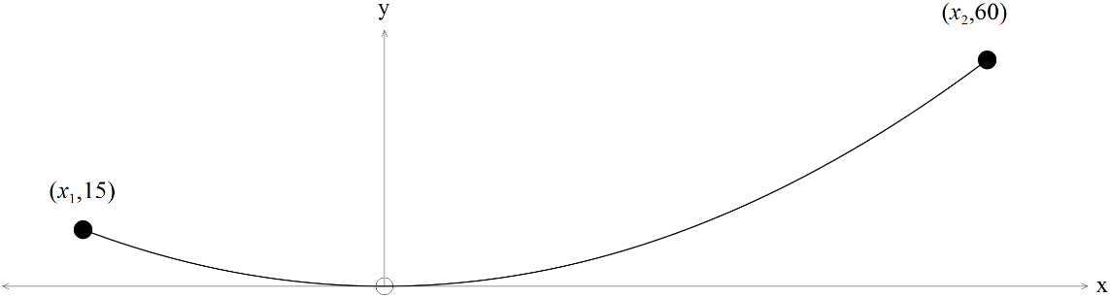

The parabola has a minimum turning point at , contains the points and .
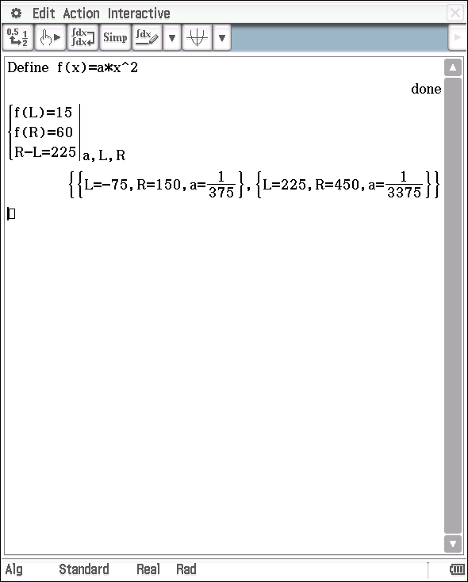
Using CAS,

Marking key/Mathematical behaviours | Marks
- Uses  - Uses distance between points  - Sets up three equations to solve for  - Determines  - Calculates length of cable | 1  1  1  1  1

TASK 11: SURFACE AREA

In-class investigation

Unit 4

Topic 4.1: Integration and applications of integration

Course-related information

The concepts and skills included in this investigation relate to the following dot points within the WA Mathematics Specialist syllabus.
4.1.2 use substitution to integrate expressions of the form
4.1.6 determine volumes of solids of revolution about either axis

Background information

The mathematical skills and understandings that students would need for this task should have been covered in earlier years and also in WA Mathematics Methods 3.2.1 – 3.2.7, 3.2.17. It is also assumed that students have already covered WA Mathematics Specialist 4.1.2 and 4.1.6 in class.

Task conditions

For this task students should not have access to a CAS calculator. No student notes are required; formulae are provided.

SURFACE AREA

In-class investigation (Total marks: 40)

When a plane curve is rotated about an axis, a hollow three-dimensional solid is created. The surface area of this solid may be determined.

The point on the curve traces out a circle whose circumference is or as it is rotated about the .

The area of a surface of revolution generated by revolving the curve about the axis is given by

The area of a surface of revolution generated by revolving the curve about the axis is given by

where .

Question 1 (13 marks)

Determine the area of the surface of revolution obtained by rotating the arc of the parabola about the using:

(a) (6)

(b) (5)

(c) Comment on your results. (2)

Question 2 (7 marks)

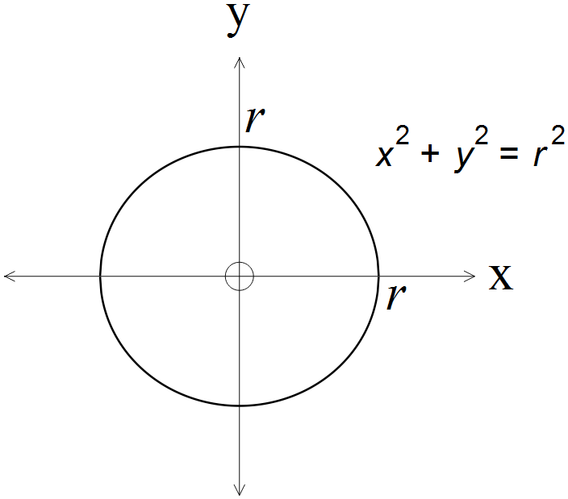

Show that the surface area of a sphere of radius is by rotating an arc of the curve about the axis.

Question 3 (12 marks)

The formula for the volume and surface area of a cone of height and radius may be determined by rotating the line segment about the .

(a) Express in terms of . (2)

Hence, by rotating this line segment about the ,
(b) show that the volume of the cone is given by . (5)

(c) determine a formula for the surface area of the cone. (5)

Question 4 (5 marks)

A group of Year 12 students is building a satellite dish whose shape will be formed by rotating the curve about the . If the dish is to have a diameter of m and a maximum depth of 0.6 m, determine the exact surface area of the dish.

Question 5 (3 marks)

If the curve is rotated about the horizontal line where determine a formula for the area of the resulting surface.

SURFACE AREA

In-class investigation
Solutions and marking key

Question 1(a)
Solution
Using where
Mathematical behaviours | Marks
- Chooses  - Correct upper and lower limits  - Substitutes correctly for  - Recognises integral of the form  - Correct antiderivative  - Correct surface area | 1  1  1  1  1  1

Question 1(b)
Solution
Using where
Mathematical behaviours | Marks
- Correct upper and lower limits  - Substitutes correctly for  - Simplifies in terms of  - Correct antiderivative  - Correct surface area | 1  1  1  1  1

Question 1(c)
Solution
Concludes that the answers to (a) and (b) are the same because
and
Mathematical behaviours | Marks
- Recognises results are the same  - Supports conclusion with reasoning | 1  1

Question 2
Solution
Rotate about the axis.
Using ,

Hence, surface area of a sphere of radius is .
Mathematical behaviours | Marks
- rotates an arc of the circle about the axis  - uses correct integral for area of surface of revolution about axis  - correct expression for  - simplifies expression for  - simplifies integral expression  - correct antiderivative  - correct conclusion | 1  1  1  1  1  1  1

Question 3(a)
Solution
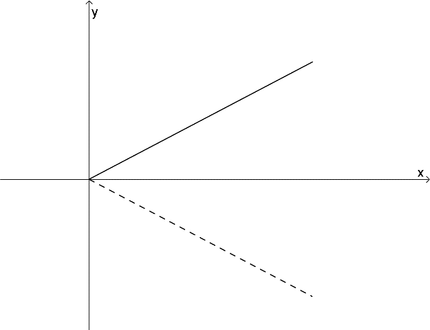

Mathematical behaviours | Marks
- Correct expression for  - Correct expression for | 1  1

Question 3(b)
Solution
Rotate the line segment , about the ,
Mathematical behaviours | Marks
- Chooses correct integral  - Correct upper and lower limits  - Substitutes for in terms of  - Correct antiderivative  - Establishes formula for volume of a cone | 1  1  1  1  1

Question 3(c)
Solution
Rotate the line segment , about the ,

Mathematical behaviours | Marks
- Chooses correct integral  - Correct upper and lower limits  - Substitutes for in terms of and for  - Correct antiderivative  - Establishes formula for volume of a cone | 1  1  1  1  1

Question 4
Solution
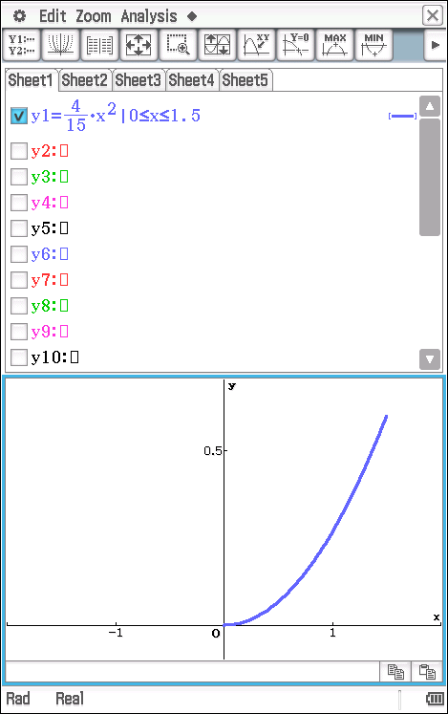

Curve passes through ,
Mathematical behaviours | Marks
- Determines  - Chooses correct definite integral  - Substitutes for  - Correct antiderivative  - Calculates surface area | 1  1  1  1  1

Question 5
Solution
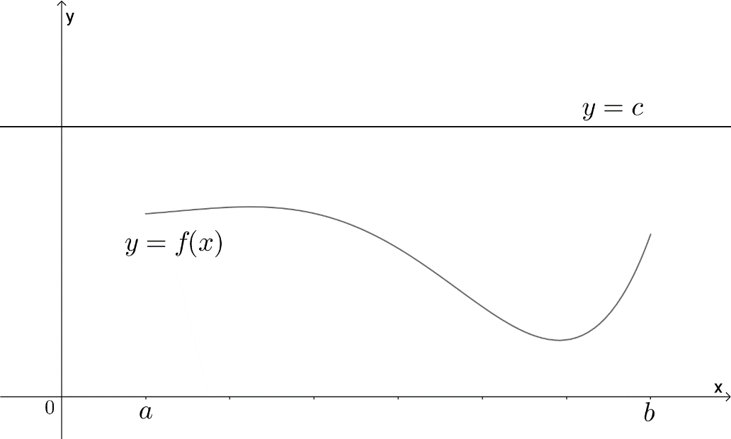

Mathematical behaviours | Marks
- Establishes radius of circle  - Establishes circumference of circle  - Determines formula for surface area | 1  1  1

TASK 12: INVESTIGATIVE QUESTIONS

Unit 4

Topic 4.1: Integration and applications

Course-related information

The concepts and skills included in this investigation relate to the following dot points within the WA Mathematics Specialist syllabus.

4.1.1 integrate using the trigonometric identities
4.1.2 use substitution to integrate expressions of the form
4.1.3 establish and use the formula

Background information

The mathematical skills and understandings that students would need for this task should have been covered in earlier years and also in WA Mathematics Methods 3.2.1 – 3.2.7, 3.2.17

Each of the questions provided are stand-alone and may be incorporated into different tasks. It is not intended that they form part of the same assessment task.

Task conditions

These questions are independent of each other and are written so that they may be incorporated into a test or examination. Students are expected to show working and the use of the CAS calculator should not be permitted. The time required to complete each question is left to the discretion of the teacher but the intention is that each question may be completed within 15 minutes.
Investigative questions for Topic 4.1

Question 1 (14 marks)

The function is given.

(a) Determine an expression for. (2)
(b) Hence determine an expression for (3)
(c) Determine an expression for
(i) (3)
(ii) (2)
(d) Determine an expression for hence evaluate (4)

Question 2 (13 marks)

Given function may be expressed as the product of differentiable functions ,
i.e. ,

(a) show that (4)

Hence, determine
(b) (4)

(c) (5)

Question 3 (11 marks)

(a) By considering the three polynomials , find the values of such that
.
(4)
(b) Using these values of , establish whether or not this formula gives the value of the definite integral for all quadratic polynomials. (4)

(c) Does the formula hold for ? (3)
Investigative questions for Topic 4.1
Solutions and marking key

Question 1(a)
Solution
Mathematical behaviours | Marks
- Applies product rule  - Correct derivative | 1  1

Question 1(b)
Solution
Mathematical behaviours | Marks
- Integrates both sides of expression  - Correct antiderivatives  - Rearranges to obtain required antiderivative | 1  1  1

Question 1(c)(i)
Solution
Mathematical behaviours | Marks
- Applies substitution  - Correct antiderivative in terms of  - Correct antiderivative in terms of | 1  1  1

Question 1(c)(ii)
Solution
Mathematical behaviours | Marks
- Applies substitution  - Correct antiderivative in terms of | 1  1

Question 1(d)
Solution
Mathematical behaviours | Marks
- Applies substitution to indefinite integral  - Correct antiderivative in terms of  - Rewrites definite integral  - Correct value for definite integral | 1  1  1  1

Question 2(a)
Solution
Mathematical behaviours | Marks
- Applies product rule  - Integrates both sides  - Rearranges  - Rewrites in terms of | 1  1  1  1

Question 2(b)
Solution
Mathematical behaviours | Marks
- Correctly chooses  - Determines  - Determines  - Correct antiderivative | 1  1  1  1

Question 2(c)
Solution
Mathematical behaviours | Marks
- Correctly chooses  - Determines  - Applies trig identity  - Determines  - Correct antiderivative | 1  1  1  1  1

Question 3(a)
Solution
Mathematical behaviours | Marks
- Uses to establish an equation in terms of  - Uses to establish an equation in terms of  - Uses to establish an equation in terms of  - Solves for | 1  1  1  1

Question 3(b)
Solution
Using ,
Hence the formula gives the value of the definite integral for all quadratics.
Mathematical behaviours | Marks
- Uses the quadratic polynomial  - Substitutes and evaluates definite integral in terms of  - Substitutes and evaluates  - Establishes statement is true | 1  1  1  1

Question 3(c)
Solution
Using ,
Hence, the formula does not hold for .
Mathematical behaviours | Marks
- Substitutes and evaluates definite integral  - Substitutes and evaluates  - Establishes formula does not hold for | 1  1  1

Mathematics From the Birth of Numbers, J Gullberg, W.W.Norton & Company, p 538
Adapted from ‘Mechanical Integration’, http://nrich.maths.org/477

